**Protractor framework Installation Guide:**

1. **Install Node.js (https://nodejs.org/en/download/)**
2. **Install Visual Studio Code (https://code.visualstudio.com/download)**
3. **Install jdk 1.8**
4. **Set path in environment variable till jdk1.8/bin**

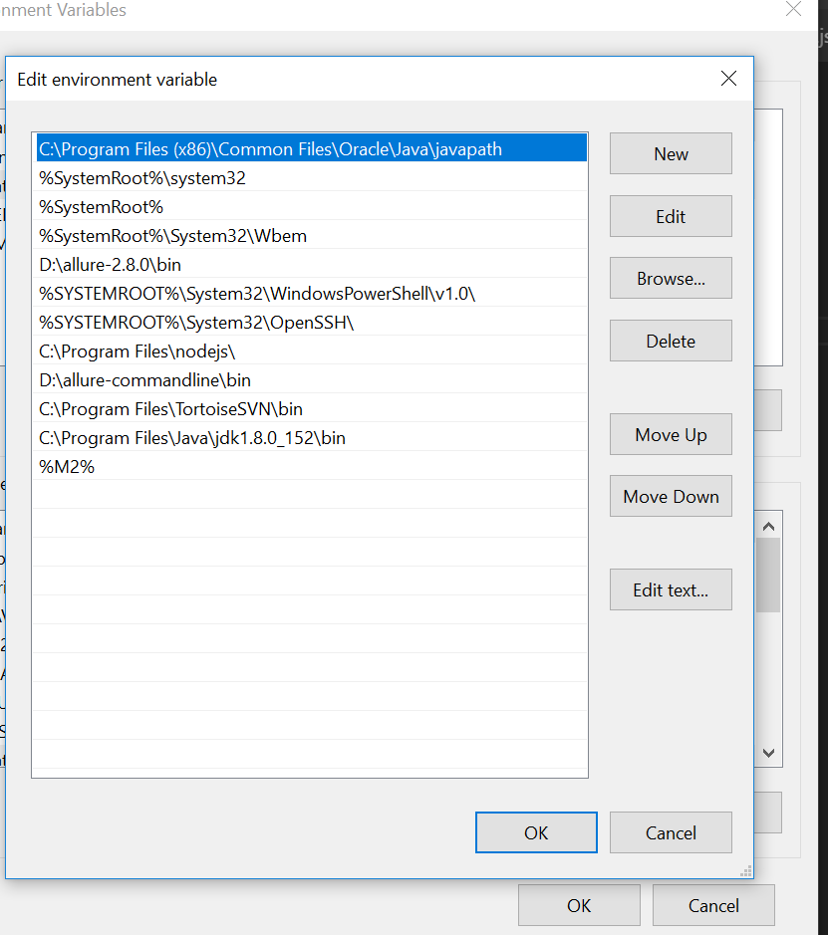

1. **Install allure: (**[**https://docs.qameta.io/allure/**](https://docs.qameta.io/allure/)**)**

Allure is used as report analyzing tool here. We can configure any other report analyzing tool as per requirement.

1. **Install Tortoise SVN:** It is used to import code from central Repository.
2. **Install Protractor :** Run this command in command Prompt

npm install –g protractor.

**Steps to execute scripts**

1) **Start selenium server :** Open command prompt and execute these commands .

a) webdriver-manager update.

b) webdriver-manager start.

If selenium server is working fine you’ll see this line:

(Selenium Server is up and running on port 4444)

Note: Sometime these commands doesn’t work on business network so you can use your own internet to start selenium server.

2) **Run config file in VS Code**

a) Open terminal in VS code

b) Go to config file directory:

(Right click on configuration files in vs code and click on Open in terminal).

c) execute this command in terminal : **protractor config.js**

d) In config file mention whichever scripts you want to run .

3) **Passing execution environment through command line:**

a) Run this command at commandline :

protractor config.js --params.Url = Pass url here

( **for ex** :protractor myconfig.js --params.Url=https://usaccounts-qa3.corp.frk.com/advisor)

**Miscellaneous Properties**

* **To switch between Headless and Non-Headless mode:**

For headless add this to **config** file => args:[‘--headless’]

For non-headless mode Remove this (args:[‘--headless’]) from args .

* **To switch or select browser for execution:**

***For chrome:***

Capabilities : {

‘browserName’ : ’chrome’,

‘chromedriver.version’ : 2.35

}

***For Firefox***:

Capabilites : {

‘browserName’ : ‘firefox’ ,

// For headless mode in Firefox add this line

‘moz.firefoxOptions’ : { args : [“ –headless”] }

}

* **For multiple browsers at same time :**

multiCapabilities: [

{

browserName: 'chrome',

 acceptInsecureCerts: true,

chromeOptions: {

args: ["--headless", "--no-sandbox", '--disable-gpu', "--window-size=1920,1080"]},

shardTestFiles: true,

maxInstances: 1,

},

{

browserName: 'firefox',

acceptInsecureCerts: true,

'moz:firefoxOptions': {

args: ["--headless","--no-sandbox", '--disable-gpu', "--window-size=1920,1080"]}

},

],

* **To run multiple instances of browsers at same time (Parallel Execution) :**

Add this command in **capabilities** in config file : maxInstances: 4,

For ex:

capabilities: {

'browserName': 'chrome',

'chromedriver.version': 2.35,

acceptInsecureCerts: true,

'shardTestFiles': true,

maxInstances: 4,